**Assignment: Kinematics**

**SPH4U**

**Virtual High School**

**Jin Hyung Park**

1. **Calculate the average velocity for a remote controlled vehicle that shows with a velocity of 1.0m/s [forward] and then accelerates at 0.05m/s^2 backward for 4.0s.**

$Average velocity=\frac{Total displacement}{Total journey time}$

$v=\frac{ut-\frac{1}{2}at^{2}}{t}=u-\frac{1}{2}at=1-\frac{1}{2}(0.08)(4.0)=1-0.16=0.84m/s$

Thus, the answer would be 0.84m/s.

1. **Use the position-time graph to complete the questions.**
2. Locate the regions where the velocity is positive.

$\vec{v}=\frac{d\vec{x}}{dt}=slope of d-t curve$ (which is given on the problem)

As we see the given graph on the problem, velocity is positive at $(0,3)∪(8,9)$.

1. Calculate the velocity at the 2s mark.

At t = 2, we can see that the distance that a vehicle has gone is about 1.8m.

At t = 4, we can acknowledge the position is about 4m.

$v=\frac{Δd}{Δt}=\frac{rise}{run}=\frac{4m-1.8m}{4s-2s}=\frac{2.2m}{2s}=1.1m/s$

Thus, the velocity at the 2 seconds is 1.1m/s.

1. Calculate the average velocity between 0s and 11s.

$V_{average}=\frac{Δd}{Δt}=\frac{-4-0}{11}=-\frac{4}{11}m/s$

Thus, the average velocity between 0s and 11s is $-\frac{4}{11}m/s$.

1. How far is the object from its starting point at the 8s mark?

As we can read how far the vehicle has gone from 0s to 8s in the graph, at t = 8, the graph (d value) is -2.

Thus, from its starting point, the object has been 2m away.

**3. A sniper fires a bullet at 120m/s at 30 degrees above the horizontal from the roof top of a high parking garage. If the bullet strikes the level ground beside the parking garage:**

1. How long was the bullet in the air?

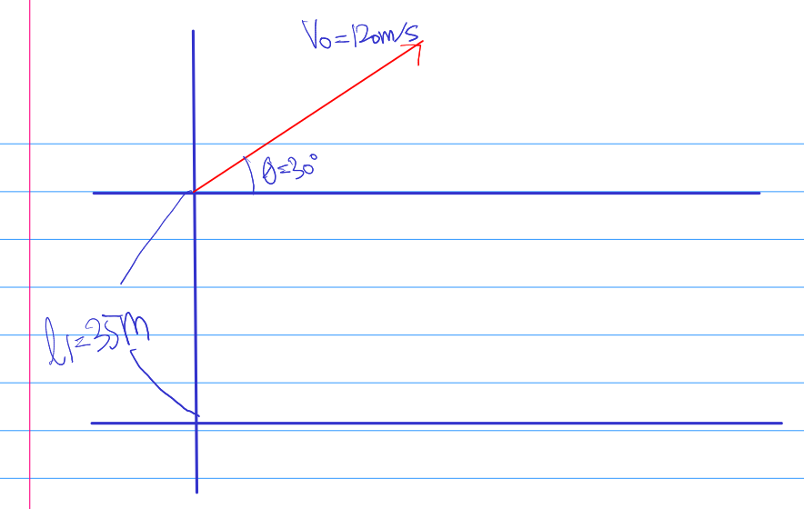

The bullet was there in the air for 5 seconds, and the vertical distance covered by the bullet, which is h is -35m.

Vertical component = $120×sin(30^{o})=120×\frac{1}{2}=60m/s$

Horizontal component = $120×cos(30^{o})=120×\frac{\sqrt{3}}{2}=104m/s$

$l_{1}=ut+\frac{1}{2}at^{2}$

$-35=60t-\frac{1}{2}(9.81)t^{2}$

$-35=60t-4.9t^{2}$

To solve the t, use the following equation.

$\frac{-b±\sqrt{b^{2}-4ac}}{2a}=\frac{-60±\sqrt{60^{2}-4(-4.9)(3.5)}}{2(-4.9)}$

$t=-0.51s and 12.75s$

To note, time cannot be a negative value.

Thus, the time for the air is 12.75 seconds.

1. How far from the base of the parking garage did the bullet land?

$distance=velocity×time$

$=t×(V_{0}cos(30^{o}))=t×(120cos(30^{o}))=12.75×104≈1331m$

Thus, the distance of the point where the bullet was landed from the parking garage is 1331m.

1. At what angle did the bullet land?

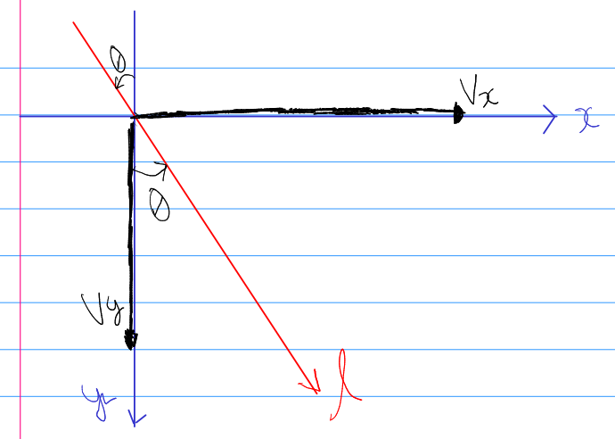

To begin with, let us think of the y-component of velocity at the landing point.

$V_{y}=V_{0}sinθ-qt=(120sin(30^{o})-9.81×12.79)=-65.469m/s$.

In addition we can think of the x-component of velocity at the landing point.

$V_{x}=V_{0}sinθ=120cos(30^{o})=103.923m/s$.

Using the aforementioned information, we can get the angle as the following.

$θ=tan^{-1}(\frac{V_{y}}{V_{x}})=\frac{-65.469}{103.923}≃-32.2^{o}$

Thus, the answer would be 32.2 degrees downward.